Light of the East Conference

June 29, 2019

Feast of Saints Peter & Paul

8am – 4pm

***Monasticism for the Rest of Us***

***Lay Monasticism is also called Interiorized Monasticism***

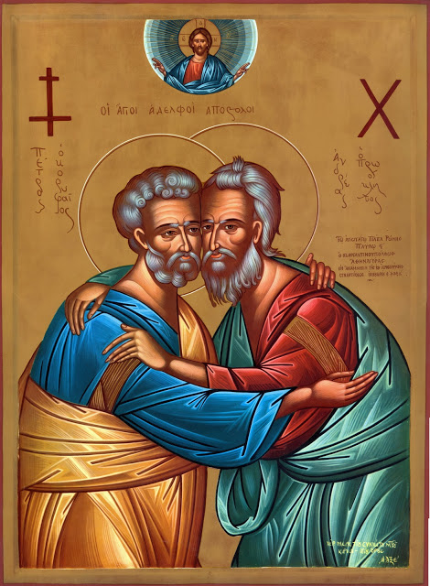

*Icon of Sts. Peter & Andrew given to Pope Paul VI by Patriarch Athenagoras in 1964*

**Sponsored by the Society of St. John Chrysostom-Western Region** [www.lightoftheeast.org](http://www.lightoftheeast.org)

**Hosted by:** *University of Saint Katherine*

1637 Capalina Road, San Marcos, CA 92069

**Presenters:**

Chris O’Donnell Roman Catholic layman, married, father of three; member of the Franciscan 3rd Order; Director of Catechetical Ministry for San Rafael Parish

Mother Melania, Abbess of Holy Assumption Monastery (Orthodox), Calistoga, CA; faculty member of Graduate Theological Union, Berkeley, CA.

Fr. George Morelli PhD, Chair of Society of St. John Chrysostom – Western Region; Licensed Psychologist & MFT; Asst. Pastor St. George Antiochian Orthodox Church, San Diego, CA; faculty (psychology) University of St. Katherine

**Conference Schedule:**

***8 am*** Registration/Coffee **9 am** Chris O’Donnell ***10 am*** Mother Melania ***11:30 am*** Prayer Service ***12:00 noon*** Lunch–Sandwiches available ***1:30pm*** Fr. George Morelli ***3 pm*** Panel of speakers Q & A

**Registration: *$25 - add extra $10 if want lunch (Make checks payable to “SSJC-WR”)***

**Please return to: *Robert Greenwell, Treasurer 2700 Katherine St., El Cajon, CA 92020***

*Advance Registration by mail or register at the door* ***Questions? 760-920-6530***

**Name_______________________________________________________________________________**

**Address____________________________________________________________________________ _____________________________________________________________________________________**

**Phone/Email________________________________________________________________________**